# Serial port control servo

## 1. Learning objectives

In this course, we mainly learn to use STM32F103C8T6 and 24-way servo drive module to realize serial port control servo.

## 2. Prepare before class

In this example, the 24-way servo driver module adopts serial port communication, and the TXD and RXD of the module are connected to the PA3 and PA2 pins of the STM32F103RCT6 board, respectively. VCC and GND are connected to the 3.3V and GND of the STM32F103RCT6, respectively.

As shown in the image:

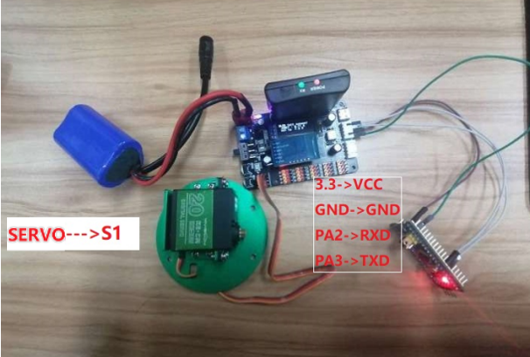

## 3. Program

Initialize serial ports, interrupts, delays, etc.

The servo control function, according to the protocol, 0x24 and 0x23 are packet headers and tails, respectively.

Control the servo S1 with a for cycle, select 5 degrees each time from 0 to 180, and finally return to 0 degrees.

## 4. Experimental phenomenon

After the program is downloaded and run, the servo turns from 0 degrees to 180 degrees, and then back to 0 degrees.